OZONE Widget Framework
Administrator’s Guide
February 4, 2014

Publication/Revision History
Release | Date
Revised OWF 7 | February 4, 2014
Revised OWF 7 | January 22, 2014
Revised – OWF 7 | December 21, 2012
Revised – OWF 6 | September 28, 2012
Revised – OWF 5 | June 29, 2012
Initial Document – OWF 4.0 | March 30, 2012

Contents
1 Introduction 1
1.1 Objectives 1
1.2 Document Scope 1
1.3 OWF Purpose 1
1.4 Supported Browsers 1
1.5 Related Documents 2
2 Administrator Tools 3
2.1 Administrative Managers 3
2.1.1 Manager Panel 3
2.1.1.1 Management Buttons: Create/Delete 5
2.1.1.2 Management Buttons: Edit 5
2.1.2 Manager Widgets—Search 9
2.1.3 Manager Widgets—Pagination 9
2.2 Widget Approval 9
2.2.1 Approving Required Widgets 10
3 Default Content 12
4 Creating and Editing Content 14
4.1 Creating Users 14
4.1.1 Adding Widgets to a User Profile 14
4.1.2 Adding Users to a Widget 15
4.1.3 Editing User Properties 15
4.1.4 User Preferences 16
4.2 Creating Widgets 17
4.2.1 Widget Descriptor URL 18
4.2.2 Editing Existing Widget Content 18
4.2.2.1 Updating and Editing Widget Descriptor Data 19
4.2.3 Exporting Widgets 19
4.3 Creating Groups 20
4.4 Grouping Widgets 20
4.4.1 Adding Widgets to a Group 21
4.4.2 Adding Default Tags 21
4.5 Creating Group Dashboards 22
4.6 Connecting to Marketplace 23
Appendix A Object Reference A-1
A.1 Dashboard Object A-1
A.2 Widget Object A-2
A.3 User Preference Object A-5
Appendix B Known Issues B-1
B.1 Browser Issues B-1
B.2 User Interface Issues B-1
Appendix C Contact Information C-1
C.1 Discussion Group C-1
C.2 Additional POCs C-1
Tables
Table 1: Tested Browsers 1
Table 2: Related Documents 2
Table 3: Edit Button and Editor Widget Fields 6
Table 4: Dashboard Object A-1
Table 5: Widget Object A-2
Table 6: Widget Object Placement A-5
Table 7: Preference Object A-5
Figures
Figure 1: Administrator Tools 3
Figure 2: Users Manager Panel 4
Figure 3: Widgets Tab on the User Editor 6
Figure 4: Management Widget Pagination Toolbar 9
Figure 5: Marketplace Approvals 10
Figure 6: Approvals Widget 10
Figure 7: Required Widget Identifiers 11
Figure 8: User Dialog/DEFAULT_USER 12
Figure 9: Default OWF Users Group 13
Figure 10: Preferences Tab 16
Figure 11: Preferences Dialog 18
Figure 12: Grouped Widgets 22

- Introduction
  - Objectives
This guide covers topics relevant to administering the OZONE Widget Framework (OWF).
  - Document Scope
This guide is intended for administrators of an OWF instance. An administrator can, for the purpose of this guide, be defined as someone who maintains OWF, as well as handles user and widget settings.
  - OWF Purpose
OWF is a set of tools, generally delivered in the OWF-bundle-7-GA.zip. When deployed, OWF is used for organizing and displaying Web applications (widgets) in a single browser window.
  - Supported Browsers
OWF supports Internet Explorer 7 and higher and Firefox 3.6 and higher. OWF is tested against the following browsers:
Table 1: Tested Browsers
Browsers | Versions
Internet Explorer | 7 & 9
Firefox | 3.6 & 15

  - Related Documents
Table 2: Related Documents
Document | Purpose
User’s Guide | Understanding the OWF user interface; adding, deleting, modifying widgets; accessing and using Marketplace; creating, deleting, adding, switching, modifying dashboards; defining accessibility features such as high-contrast themes and keyboard navigation
Administrator’s Guide | Understanding administrative tools: adding, deleting, and editing widgets, users, groups and group dashboards; creating default content for users, groups and group dashboards
Developer’s Guide | Creating Widget applications and integrating existing applications into OWF; widget upgrade instructions; walkthroughs for creating widgets; adding the following components to widgets: descriptor URLs, preference API; logging and launching API
Configuration Guide | Overview of basic architecture and security; OWF installation instructions; instructions for modifying default settings; database set up and logging guidance; framework and theme customization instructions; OWF upgrade instructions; directions for adding and deleting help content
Quick Start Guide | Walkthrough of basic OWF functions such as using widgets and dashboards; instructions for setting up a local instance of OWF, unpacking the OWF Bundle and installing security certificates; Truststore/Keystore changes
- Administrator Tools
Administration tools, located by clicking the Administration button on the toolbar, allow an administrator to manage widgets, groups, users and group dashboards. If Administrators use the Marketplace Approvals Widget, it will appear here by default.

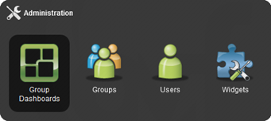
Figure 1: Administrator Tools
  - Administrative Managers
The administration managers are used to create, edit and delete users, groups, widgets and group dashboards as well as approve listings imported from Marketplaces. While each manager has specific fields that relate to the manager’s specific purpose, some of the functions operate identically in each manager. For example, the search feature in the User Manager functions exactly like the search feature in the Widget Manager. Accordingly, search is explained only once in this section.
Also, this document no longer contains definitions regarding basic information that general users should understand. If a topic can be easily defined by Google, it has been removed from this guide. The following section offers a general overview of the administrative managers and their use.
The manager information is broken into sub-sections:
- Panel
- Management buttons
- Search bar and pagination toolbar
    - Manager Panel

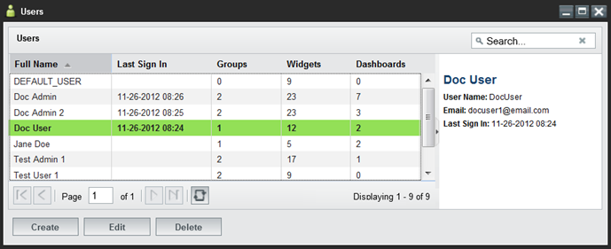
Figure 2: Users Manager Panel
The dashboard, widget, group and user managers open to similar panel views. The panel view described in this section applies to all five managers.
The Panel View:
- Allows the user to create, edit, delete or view an entry.
- Displays the number of users/groups/widgets/dashboards associated with the specific entry.
Note: When viewing the widget count, only the widgets that a user requests or receives from an administrator appear in the overall count. Widgets associated through groups will NOT appear in the widget count.
- Offers a view of the first fifty results in alphabetical order. Additional results can be viewed using the pagination as described in section 2.1.3 : Manager Widgets—Pagination. To reduce the number of displayed results: Use the search bar, described in section 2.1.2 : Manager Widgets—Search.
From the panel, an administrator can:
- Sort - Most of the columns in the panel can be sorted in ascending or descending order by clicking on the triangle to the right of the column header and selecting a sorting option.
- Hide/Show columns - Columns can be hidden or shown by hovering over a column header, clicking the triangle that will appear, hovering over the columns menu option, and un-checking the columns to be hidden.
- Reorder columns - Columns can be reordered by clicking (and holding) a column header down and then dragging it to the desired position.
- Multiple selection - Entries can be selected for bulk operations by holding down the CTRL button while clicking multiple entries. The delete, edit, activate and deactivate buttons will perform bulk operations on all selected entries.
- View the information panel - To display more information about the entry, single-click the row to open the information panel on the right.
      - Management Buttons: Create/Delete
Administrators use the manager widgets to create and delete users, widgets, groups and group dashboards. Differences between the four managers are referenced in sub-bullets.
- Launches the editor widget. From the editor, an administrator can create a new user/widget/group/group dashboard (depending on which editor the administrator launches) and assign related data to the new entry.
  - When creating a new entry, only the Properties tab will be active until the administrator saves the user/widget/group/group dashboard via the Apply button.
- Deletes selected entries. Some user/widget/group/group dashboard rules apply:
  - Deleting a group does not delete the users or widgets assigned to the group. It only deletes the pairing of users with widgets in the group.
  - Deleting a widget removes it from a user’s Launch Menu and the groups to which it was assigned.
  - Deleting a group dashboard removes it from the group. Individual users can continue to use their copy of the dashboard. However, the user’s individual copy will no longer have the option to restore to the group dashboard as described in section 4.5 : Creating Group Dashboards.
      - Management Buttons: Edit
- Clicking Edit on any administrative manager will launch the respective user/widget/group/group dashboard, allowing an administrator to edit the entry.
Note: If an administrator launches the editor widgets in a fit dashboard, the editor widgets will “float” on top of the dashboard. Additional dashboard layout information is found in the User’s Guide.
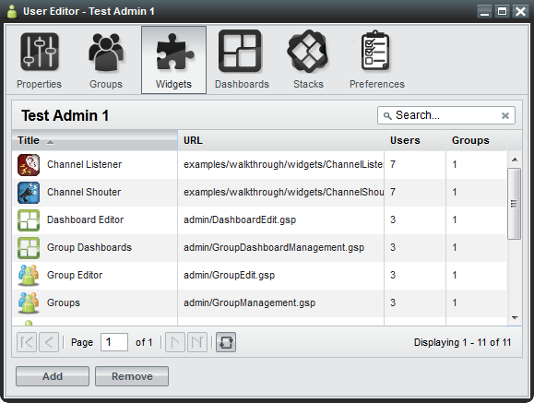
Figure 3: Widgets Tab on the User Editor
From the editor widget, administrators can create, edit and delete data assigned to users/widgets/groups/group dashboards. The following table alphabetically lists editable fields found in the editor widgets. Split Edit button features, located in the manager widgets, are also listed. The last column of the table describes the location of each field.
Table 3: Edit Button and Editor Widget Fields
Field | Purpose | Location
Activate/Deactivate | Users in active groups have full access to their group-assigned widgets. Users in a deactivated group will not have access to any of the widgets which are assigned to them via the deactivated group. When a group becomes deactivated it will appear gray.  Note: If a user is in Group A and Group B and each group has Widget 1 assigned to it, the user will still have access to Widget 1 if Group A is deactivated and Group B is activated. Additionally, if the user has widget access outside of a group’s distribution, the user will not lose access to the widget, even if they lose group access. | Group Manager (under the split Edit button);  “Active” checkbox in the Group Editor, Properties Tab
Background | Some widgets do not have user interfaces. These widgets are often used to cache or log data. If a widget is set to run in the background, it will not appear in the dashboard foreground. However, it will appear in the Widget Switcher (Alt + Shift + Q). Also, it will appear on the user’s Launch Menu if the “visible” menu flag (described in this table) is turned on. | Widget Editor, Properties Tab
Container Icon URL | Defines the location of the icon which appears in widget chrome at 24x24 pixels. | Widget Editor, Properties Tab
Copy To Group | Allows an administrator to copy dashboards to selected groups via the add groups window. Once a dashboard is added to a group, every member of that group will receive their own copy of that dashboard. | User Editor, Dashboards Tab, split Edit button
Default Tags | Specifies the default tags (comma separated, if needed) that facilitate widget categorization. Default tags cannot be deleted by the user; however, users can add additional tags to widgets in their instance of OWF. Default Tags are superseded by grouped widgets, which are explained in section 4.4 : Grouping Widgets. | Widget Editor, Properties Tab
Definition | A required field in a dashboard that contains the JSON configuration of a dashboard. | Dashboard Editor, Properties Tab
Display Name | The group name which will appear in grids and tables throughout administrator views. | Group Editor, Properties Tab
GUID | A unique 32-character alpha-numeric code for a particular named widget. If “Widget A” is launched 5 times, all 5 widgets will share the same widgetGuid property. | All Editor Widgets, Properties Tab
Height | Defines the launch height of the widget in pixels. Up and down arrows to the right of the field can be used to modify the overall height. | Widget Editor, Properties Tab
Launch Menu Icon URL | Defines the location of the icon which appears in the Launch Menu (at 128 x 128 pixels), provided the “visible” menu flag (mentioned below) is checked. | Widget Editor, Properties Tab
Remove | Separates the selected user/group/widget/dashboard from the selected entry. This does not delete the user/group/widget/dashboard from the system. It only removes the assignment to the selected entry. | All Editors
Singleton | Designates whether a widget can only have one instance launched per dashboard. | Widget Editor, Properties Tab
Universal Name | A value that can be used as a widget’s global identifier across all instances of OWF. This differs from a widget GUID which is unique to a specific installation. | Widget Editor, Properties Tab
URL | Defines the location of the web application to which the widget icon will link. This is a required field. | Widget Editor, Properties Tab
User Management | Defines whether or not the group is an automatic group, being populated and maintained by external sources. This value cannot be modified once the group has been created. | Group Editor, Properties Tab
Version | Displays the version number of the listing. This is completely user-driven and is for informational purposes. | Widget Editor, Properties Tab
Visible | Dictates whether a listing will show in a user’s Launch Menu. This cannot be overridden by the user. | Widget Editor, Properties Tab
Widget Type | A drop-down menu for selecting the widget type which determines where the widget will be located. Only standard widgets appear in the Launch Menu. Administration widgets will appear under the Administration button on the toolbar. Widgets set to type Marketplace will appear under the Marketplace button on the toolbar. Metric widgets appear under the Metric button on the toolbar.  Note: Instructions explaining how to associate OWF with a Metrics Service are found in the OWF Configuration Guide. | Widget Editor, Properties Tab
Width | Defines the launch width of the widget in pixels. Up and down arrows to the right of the field can be used to modify the overall width. | Widget Editor, Properties Tab

    - Manager Widgets—Search
- Reduces the entries displayed in the panel to entries containing the specified word or characters entered in the search bar. Clicking the X button will clear the filter and display all entries in the panel. Clicking the search magnifying glass button will apply the search and display the filtered results in the panel.
Note: This is a full-text search and it is NOT case-sensitive.
    - Manager Widgets—Pagination
Figure 4: Management Widget Pagination Toolbar
- 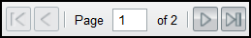 - Navigates between pages of results displayed in the search results panel.
- - Refreshes the results in the search results panel, maintaining the current filtering and sorting options.
- 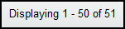 - Displays the number of results being shown against the overall total in the system.
  - Widget Approval
By default, widgets are automatically added to a user’s Launch Menu when the user adds them from Marketplace. The widgets will be available for use immediately. However, administrators can configure OWF to store widgets in a pending state until they are approved by an administrator. In that case, widgets will not be available to users until an administrator approves them.
Note: Find instructions for enabling the Widget Approvals feature and adding the Approvals Widget in the OWF Configuration Guide.
To approve pending widgets, an administrator must navigate to the Approvals Widget by clicking the Administration button on the toolbar and then selecting Approvals.

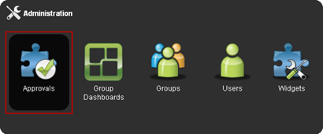
Figure 5: Marketplace Approvals
The Approvals Widget will open, which lists all the widgets pending approval. The list can be sorted by Widget or Requesting User.
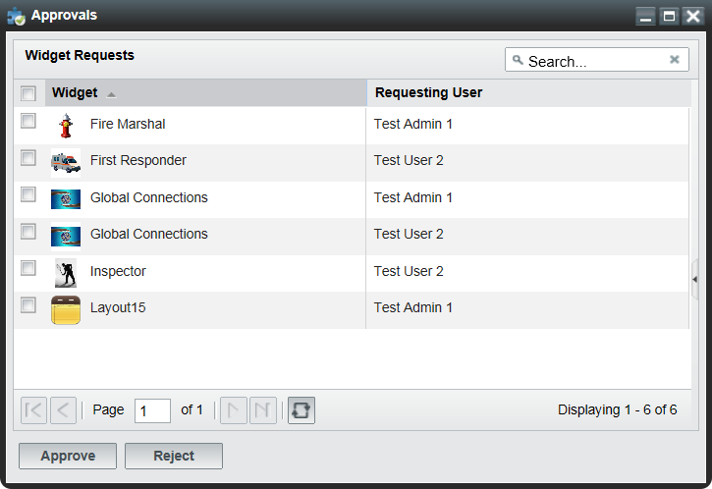
Figure 6: Approvals Widget
To approve or reject widgets:
- Check the checkbox to the left of a pending widget or widgets.
Note: Widgets must be approved or rejected for each user. Approving a widget for one user will not approve it for another.
- Click Approve or Reject at the bottom of the window.
- After approving the widget, it will appear in the requesting user’s Launch Menu. If a widget is rejected, it will be removed from the Approvals Widget.
    - Approving Required Widgets
A Marketplace listing can require other Marketplace listings. For example, if a user requests Widget A and it requires Widget B, the user automatically requests Widgets A and B. This relationship is further explained in the OWF User’s Guide.
If the instance of OWF allows users to bypass the pending approval process, those users will immediately receive all requested Marketplace widgets along with any required widgets that they need.
In the Approvals Widget, an administrator has two ways to identify that a Marketplace listing requires other Marketplace listings. When a listing is selected:
- The details section of the listing will display: Requires Widgets: true
- Its requirements will appear below the listing details
Both identifiers are highlighted in the following example:
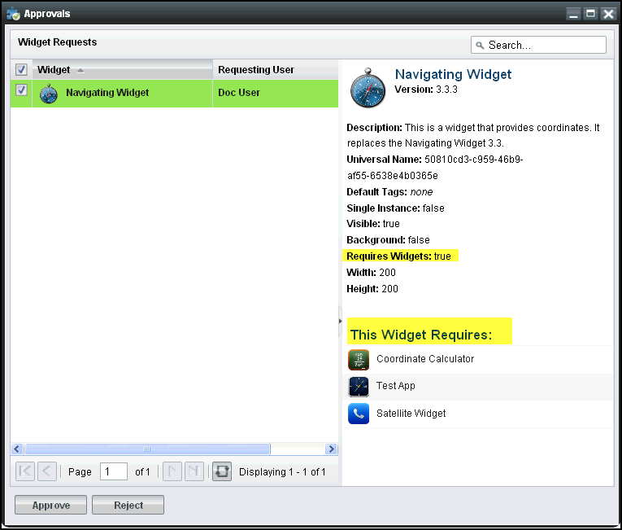
Figure 7: Required Widget Identifiers
If an administrator approves a widget that requires other widgets, the required widgets will be automatically approved.
- Default Content
OWF ships with a default user profile and default user group. Administrators can use the default profile and default group to add widgets and dashboards to a user or several users’ instance of OWF.
DEFAULT_USER – A default user profile that ships with OWF. The DEFAULT_USER data will automatically be assigned to every new user of a particular OWF installation.
When a new user enters OWF for the first time, the DEFAULT_USER data will be applied and copied to that user’s profile. After the initial login, any changes that the user makes will only impact their data from that point on. The DEFAULT_USER data remains unchanged and will continue to be applied to all new users.
Note: If an administrator makes changes to the DEFAULT_USER data set, it will only impact the users who log in for the first time, following the change. Any users who received the data prior to the change will not be affected.

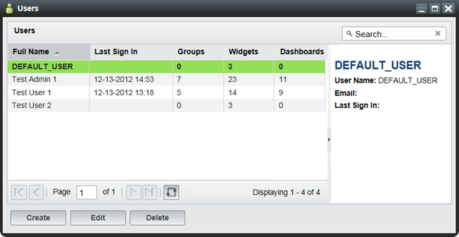
Figure 8: User Dialog/DEFAULT_USER
OWF Users – A default user group that ships with OWF. Every new user is automatically assigned to it.
When a new user enters OWF for the first time, the OWF Users group data will be applied and copied to that user’s profile. After the initial login, any changes that the user makes will only impact their data from that point on. However, if an administrator changes the OWF Users Group, the change will be applied to all users who have access to the group.
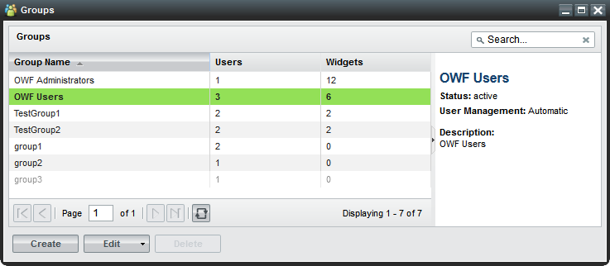
Figure 9: Default OWF Users Group
OWF Administrators - A default group that ships with OWF. Every new administrator is assigned to this group.
Data from the OWF Administrators group is automatically applied to the administrator’s profile. Users cannot be assigned to this group and administrators cannot delete the editor and manager widgets populating this group.
Note: The OWF Administrators and OWF Users groups cannot be deleted, renamed or deactivated. In the event that either group is single-selected, the delete button will be grayed out. If either (or both) groups are selected along with other manual groups, the delete button will be active. However, upon clicking Delete, only the manual groups will be removed from the system.

- Creating and Editing Content
Creating and editing users, widgets, groups, and group dashboards is explained in this section. This includes adding widgets/groups/group dashboards to user profiles through the User Editor. OWF also allows administrators to add users to widgets/groups/dashboards through the Users tab on the respective editor widgets. These examples are described in sections 4.1.1 : Adding Widgets to a User Profile and 4.1.2 : Adding Users to a Widget.
  - Creating Users
Administrators have the ability to create new user profiles, edit existing user information and add widgets/groups/dashboards to user profiles. See To create a new user profile:
- Click the  button on the toolbar.
- Choose the Users button to open the User Manager.
- Click on the Create button, opening the User Editor.
- Enter the user’s information. Mandatory fields (User Name and Full Name) are denoted with a red asterisk. More information about these fields is found in Table 3: Edit Button and Editor Widget Fields.
- When complete, click Apply. This will activate the additional tabs in the User editor.
- To add widgets, groups, or dashboards to a user account, proceed to the instructions in sections 4.1.1 : Adding Widgets to a User Profile or 4.1.2 : Adding Users to a Widget.
Note: Administrators do not create or maintain user passwords in the OWF interface. Security and authentication are addressed in the OWF Configuration Guide.
    - Adding Widgets to a User Profile
The following instructions describe how to add widgets to a user account using the Widgets tab found in the User Manager. Administrators can follow this basic formula to add groups and dashboards to user profiles via the Groups or Dashboards tabs in the User Editor widget. When assignments are complete, all of the data applied to the user profile will be instantly available.
To add widgets to a user’s account:
- Click the button on the toolbar.
- Click the Users button to open the User Manager.
- From the manager, select a User. Then, click Edit to open the User Editor.
- Click the Widgets tab at the top of the editor. Widgets that are already associated with the user will display in the window.
- To add widgets, click the Add button. A modal window will display all widgets available to that user. Select a widget, then, click the OK button. The widget will be automatically added to the list of widgets on the user’s Widget tab.
    - Adding Users to a Widget
Another way to give users access to widgets is to add users to widget profile via the Widget Editor. Again, administrators can use this general procedure to add users to groups and dashboards through the Users tabs in the respective editors. When completed, close the editor window and the data will be updated automatically to the user profile.
To add users to widget profiles:
- Click the button on the toolbar.
- Click the Widgets button to open the Widget Manager.
- From the manager, select a widget. Then, click Edit to open the Widget Editor.
- Click the Users tab at the top of the editor. Users that are already associated with the widget will display in the window.
- To add users, click the Add button. A modal window will display all users available to that widget. Select a user, then, click the OK button. The user will be automatically added to the list of users on the widget’s Users tab and the widget will be available to the user’s instance of OWF.
    - Editing User Properties
To edit existing user content:
- Click on the toolbar; select Users to open the User Manager.
- From the manager, select the user account that needs to be updated and click Edit.
- Update data on the Properties tab and click Apply. Update each field, then click Apply. For definitions of less common fields, see section Table 3: Edit Button and Editor Widget Fields.
This procedure is also used when editing the properties of widgets, groups and group dashboards. To edit the content, click on Administration button on the toolbar and click on the open the respective manager and click Edit to open up the editor. Make changes in the Properties tab and click Apply.
    - User Preferences

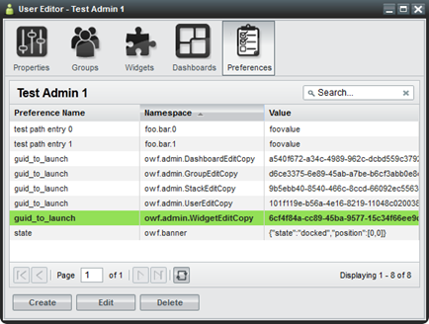
Figure 10: Preferences Tab
Widgets use preferences to store data. Preferences include widget location on the screen, launching instructions, etc. A preference value can be created and saved any time a widget performs an action. Once that preference is saved to the database, it will appear on the preferences tab in the User Editor. The Preferences tab serves as a table of known preferences. From the tab, administrators can view, create, edit and delete preferences. However, from the Preferences tab, the administrator cannot configure a widget to use a preference. For a widget to respond to preferences, the widget must be configured via the Preference API.
If a widget is configured to use preferences, they can be used to define screen location, widget interaction, etc. For example, the guid_to_launch preference is a useful eventing tool. Administrators can use it to make a tracking widget launch a map widget. For example, in , the guid_to_launch preference causes the User Manager to launch a copy of the Widget Editor.
The Preferences tab includes the following fields:
- Preference Name - The preference name is referred to as the “key” for the preference item. It lists the name of the preference as dictated by the widget or OWF. If the widget uses preferences, OWF will add the preference name to the table on the Preference tab whenever the action that is associated with the preference is performed.
- Namespace - The namespace is the identifier for the widget or system category. Generally these identifiers will describe general functionality for a widget or set of widgets.
- Value - Stored inside of the preference, values house the data that the preference uses. An example could be the actual widget GUID value that the preference will use to launch a widget. This is a string value but developers can use JSON or REST URIs as the preference value.
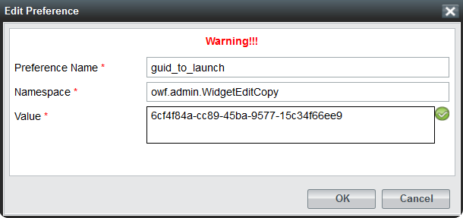
Figure 11: Preferences Dialog
  - Creating Widgets
Administrators can create, edit, delete, import and export widgets. There are two ways to create a widget: importing widget data with a descriptor URL or manually entering widget data. Imported widget data is editable through the Widget Editor (see 4.2.2 : Editing Existing Widget Content).
To create a widget, the administrator must complete several mandatory fields in the Widget Editor. Information about each widget data field is found in Table 3: Edit Button and Editor Widget Fields. For example, the Widget Type field is useful for separating widgets on a user’s toolbar. Only Standard widgets will appear in the Launch Menu. Administration widgets will appear under the Administration button on the toolbar. Widgets set to type Marketplace will appear under the Marketplace button on the toolbar. Metric widgets will appear under the Metric button on the toolbar.
To create a widget:
- Click the button on the toolbar.
- Click the Widgets button to open the Widget Manager.
- From the manager, click the Create button to open the Widget Editor.
- From here, there are two ways to create widgets:
  - Import a descriptor URL—Enter a descriptor URL and click Load. For more information about descriptor URLs see section 4.2.1 : Widget Descriptor URL.
  - Manually enter data—If a descriptor URL is not available, click the “Don’t have a descriptor URL?” link and complete the required fields on the Properties tab. Remember that the Widget Type will dictate the location of the widget. For more information about specific entry fields, see Table 3: Edit Button and Editor Widget Fields.
- Click Apply. This will unlock the Users andGroups tabs on the Widget Editor. Select each tab and click the Add button to add users and groups to the widget.
- Refresh OWF. The new widget will appear under the respective toolbar button. For more details about connecting to Marketplace(s), see 4.6 Connecting to Marketplace.
    - Widget Descriptor URL
Descriptor URLs allow an administrator to create widgets without entering the widget's information manually. The administrator simply enters a URL and the widget's information is automatically retrieved from a descriptor file from a Web-accessible location. Starting with OWF 7, widgets created with a descriptor URL are editable in the Widget Editor.
Descriptor URLs offer several benefits. They reduce the risk of typing errors when entering widget data. They allow for several installations of OWF to easily share widget information via the descriptor file.
    - Editing Existing Widget Content
To edit existing widget content:
- Click on the toolbar, select Widgets to open the Widget Manager.
- From the manager, select a widget and click Edit.
- Edit the widet data on the Properties tab and click Apply. For definitions of less common widget data fields, see Table 3: Edit Button and Editor Widget Fields.
Users and groups assigned to the widget will receive the widget data changes automatically.
      - Updating and Editing Widget Descriptor Data
Starting in OWF 7, administrators can update and edit the widget descriptor data within the OWF interface. Updating the widget descriptor data retrieves the latest data in the widget’s descriptor file which is saved in a Web-accessible location. Changes made to the widget prior to the update are lost once the update is performed.
To update the widget descriptor data:
- Click on the toolbar, select Widgets to open the Widget Manager.
- From the manager, select a widget and click Edit.
- Click Load. The Widget Editor will automatically refresh and display the most recent widget descriptor data.
- Click Apply.
Administrators can edit their copy of the widget descriptor data by following the steps outlined in section 4.2.2 Editing Existing Widget Content. Descriptor data changes are sharable after the administrator exports the widget and saves the descriptor file in a Web-accessible location. Individuals who already have access to this widget will have to update their copy of the widget’s descriptor data in order to see the widget changes in their OWF instance.
    - Exporting Widgets
Starting with OWF 7, administrators can export and save widget data as a descriptor file. An administrator needs to host the widget descriptor file in a Web-accessible location to make the file sharable with other administrators that have access to this location. This process is intended to provide a means for administrators from different OWF instances to add/receive identical widgets.
To export a widget:
- Click the button on the toolbar.
- Click on the Widgets button to open the Widgets Manager.
- Select the widget to export. Click the arrow on the right of the split Edit button and choose Export.
- Enter a File Name that describes the widget, this will become the title of the HTML descriptor file. Then click OK.
Note: If the widget was created by a descriptior file, the File Name field will be prepopulated with the descriptor file name.
- Save the widget descriptor HTML file on a Web-accessible server.
  - Creating Groups
Groups allow administrators to easily add or remove widgets and dashboards to and from multiple users’ instances of OWF. For example, by putting 10 employees into a group, the administrator can send 1 dashboard or 1 widget to the group, rather than having to individually add the widget to ten employees.
The following serves as a walkthrough for documentation purposes only. To create groups in OWF and to add users to that group:
- Click the button on the toolbar.
- Click the Groups button to open the Groups Manager.
- From the manager, click the Create button. This will launch the Group Editor.
- Fill in the appropriate data on the Properties tab. Once the Apply button is clicked, the other tabs on the Group Editor will become active. Note the following:
  - If the display name field is populated, that is the name which will appear in all administrator panels. The only way for the primary name field to appear is to leave the display name field blank.
  - If an administrator checks the automatic box in the User Management field, the following will happen:
    - The name of the group will not be editable.
    - The users tab will remain grayed out as users can only be added via external sources, such as a security plugin.
- Add users to the group by selecting the Users tab, clicking the Add button and selecting users from the grid.
- The Widgets and Dashboards tabs behave the same way and can be used to populate groups accordingly.
  - Grouping Widgets
Administrators can use groups, group dashboards and default tags to categorize and separate widgets on users’ Launch Menus. Administrators add widgets to a dashboard and then give group(s) access to that dashboard to group widgets via the group dashboard feature explained in section 4.5 : Creating Group Dashboards. Administrators also use groups and default tags to group widgets. Information about adding widgets to groups and default tags is found in the following sections.
    - Adding Widgets to a Group
When a user is part of a group, for example Group A, the user’s Launch Menu will display the widgets assigned to Group A in the main section of the Launch Menu. A list of the user’s group displays in the left panel. By checking the box to the left of the group name, the Launch Menu and Favorites Pane will only display widgets that are associated with the group, as shown below. Only an administrator can make changes to widgets that are part of a group. Users cannot edit or delete the group or the widgets in it.
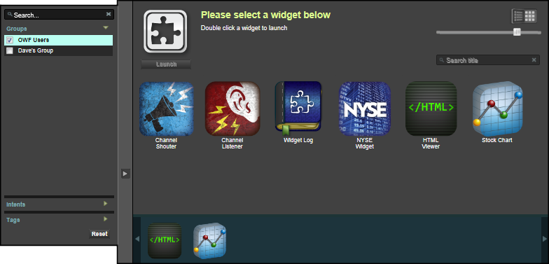
Figure 12: Grouped Widgets
To add widgets to a group:
- Click the button on the toolbar.
- Click the Groups button.
  - Select an existing group and click Edit.
- The Group Editor will launch.
  - Select the Widgets tab.
- Click Add to select widgets that will be assigned to the group, then click OK.
- Close the Group Editor.
    - Adding Default Tags
Section 4.4.1 : Adding Widgets to a Group described one method administrators can organize widgets for users in a group. Administrators can also add Default Tags to widgets to categorize them on all users’ Launch Menus. To add a Default Tag:
- Click the button on the toolbar.
- Click the Widget button to launch the Widget Manager. Then, select a Widget.
- Click Edit to open the Widget Editor.
- Add a Default Tag, then click Apply.
- Close the Widget Editor window. In every user’s Launch Menu, the widget will appear in the newly created Default Tag category.
In addition to Default Tags, users can add their own tags to widgets. The user-applied tags will only appear in the user’s instance of OWF.
Note: Default tags are not applied to Administration, Marketplace or Metrics widgets. Also, if a default tag is added to a widget after the widget is assigned to a user (visible in their Launch Menu), the Default Tag will not apply unless the widget is deleted from the user’s instance and reassigned to the user.
  - Creating Group Dashboards
Group dashboards allow members of a group to have identical copies of a dashboard. Similar to the OWF Users Group, administrators can use group dashboards to give different groups of users the same starting screen or access to widgets. Each user can customize their instance of the group dashboard. Those changes will ONLY affect that user’s instance of the dashboard. Users can return their dashboard to the current state of the group dashboard by clicking the button (found by clicking Manage on the Switcher, then choosing the dashboard). If an administrator changed the group dashboard after it was added to a user’s instance of OWF, the current state of the dashboard may be different than the one that originally appeared on the user’s navigation bar.
Note: If a group dashboard is deleted by an administrator, the users’ copies of that dashboard will remain available to the users. However, the restore feature will no longer be available for the dashboard.
To create a group dashboard:
- Click the button on the toolbar.
- Open the Group Dashboards Manager.
  - Select an existing dashboard and click Edit.
  - Click Create to make a new dashboard.
- Customize the fields on the Properties tab, then click Apply.
- To add a group, select the Groups tab and click Add. Select the group you want to add, then click OK.
- Close the window. Each user in the selected group will see the dashboard in the dashboard switcher on their toolbar.
  - Connecting to Marketplace
Marketplace, similar to a commercial application store, operates as a thin-client registry of applications and services. Marketplace allows administrators to connect to multiple Marketplaces by creating widgets that are stored under the Marketplace button on the toolbar.
To enable the Marketplace button on the toolbar, an administrator has to create a Marketplace widget. To do this, follow these instructions:
- Sign in to OWF as an administrator.
- Click the  button on the toolbar and select Widgets.
- Click Create and complete all the fields, change the Widget Type field to Marketplace.
- Click Apply.
- When you refresh OWF, the Marketplace button will appear on the toolbar. Repeat the process for each different Marketplace connection.

Object Reference

Dashboard Object
Table 4: Dashboard Object
Property | Sample Value | Description
guid | 1d789781-e4e5-5acb-f9c5-eae28adf7699  (A unique 32-character alpha-numeric code) | A unique identifier for the dashboard.  Note: The guid is only required to be unique within the dashboard table.
columnCount | 0 | Deprecated
isdefault | True/False | Legacy Code. This is no longer applicable.
layoutConfig | {  "xtype":  "desktoppane",  "flex": 1,  "height": "100%",  "items": [],  "paneType":  "desktoppane",  "widgets": []  } | Holds the various panes on a dashboard and the widgets inside of the panes, including the widget states.  Note: Appendix A.2 : Widget Object describes the content of “widgets”.
layout | N/A | Deprecated
EDashboardLayoutList | N/A | Deprecated
name | Customizable | This is a User-driven field. Even if a Dashboard loads a default name, the User can modify it at will.
state | N/A | Deprecated
groups | Customizable | When a group is associated with the dashboard, it becomes the value for the “Groups” attribute.
isGroupDashboard | True/False | Identifies if the dashboard is associated with a group.
description | Customizable | A description of the dashboard.
defaultSettings | N/A | Deprecated
createdDate | 02/09/2012 11:48 AM EST | Date when the dashboard was created.
editedDate | 02/09/2012 11:48 AM EST | Date when the dashboard was last edited.
createdBy | userId: “”  userRealName: “” | The user name and id of the dashboard creator.
user | Customizable | When a name is used to validate a security protocol, it becomes the value for the “User” attribute.
alteredByAdmin | True/False | If a user’s dashboard has been modified via the Administration UI, this value will appear as true.

Widget Object
Table 5: Widget Object
Property | Sample Value | Description | Dashboard Layout Type: Accordion, Tabbed, Desktop, Portal, Fit
uniqueId | 1d789781-b4a5-512b-ea59-eae28adf7699 | A unique 32-character alpha-numeric code. representing a widget’s state as it exists on a dashboard instance | All dashboards which contain widgets  Note: This value is not associated with a widget’s state within a dashboard until the widget is launched – then the uniqueId is created.
widgetGuid | 1a718777-b4a5-512b-ea59-eae28adf7699  (A unique per widget 32-character alpha-numeric code) | A unique 32-character alpha-numeric code for a particular named widget. If “Widget A” is launched five times, all five widgets will share the same widgetGuid. | All Widgets
universalName | Ozone.OWF.ChannelShouter | A user-generated, custom identifier which is a permanent element of the widget across multiple instances. This differs from a widgetGuid which is unique to a specific installation. | All Widgets
widgetVersion | 1.0 | A string which indicates the software version of the Widget. | All Widgets
name | “Widget B” | Up to 50 alpha numeric characters. | All Widgets
active | True/False | Dictates which particular Widget on a dashboard is active upon launch. | Tabbed  Desktop
width | 225 | Widget width in pixels. | All Widgets
height | 400 | Widget height in pixels. | All Widgets
minimized | True/False | Dictates whether a Widget is at its minimized size. | Tabbed  Desktop  Floating Widgets
maximized | True/False | Dictates whether a Widget is at its maximized size. | Tabbed  Desktop  Floating Widgets
pinned | True/False | Denotes whether a Widget is pinned in place or not. | Accordion
collapsed | True/False | Denotes whether a Widget is collapsed to its chrome. Dashboard types (on right) are what differentiate this attribute from the minimized definition. | Portal  Accordion
floatingWidget | True/False | Denotes whether a Widget is floating over an entire dashboard and not constrained to a single layout type. Example: Widgets launched from a widget in a fit pane open as floating widgets. | Fit
Column | N/A | Deprecated | N/A
buttonID | N/A | Deprecated | N/A
buttonOpened | N/A | Deprecated | N/A
region | N/A | Deprecated | N/A
The following three values are stored in the database for stateful purposes but are not part of the widget definition or widget creation process. They are used to determine widget placement on a dashboard.
Table 6: Widget Object Placement
Property | Sample Value | Description | Dashboard Layout Type :Accordion, Tabbed, Desktop, Portal, Fit
X | 200 | The ‘X’ value represents the physical location (from the upper left-hand corner of OWF) in which the widget will spawn. | Tabbed  Desktop  Floating Widgets
y | 500 | The ‘Y’ value represents the physical location (from the upper left corner of OWF) in which the widget will spawn. | Tabbed  Desktop  Floating Widgets
zIndex | Variable number | A relative number representing which widget is “on top” of an overlapping cluster of widgets – thus making it the visible widget. | Tabbed  Desktop  Floating Widgets

User Preference Object
Table 7: Preference Object
Property | Sample Value | Purpose
Preference Name | ClockWidgetSettings | User driven – defines the overall preference description. This is the effective key of the preference object that identifies the specific preference.
namespace | TimeType | Used to uniquely identify a widget preference. The OWF team recommends using namespaces similar to java packages, i.e. com.mycompany.widgetname.
value | 24hrMilitary | This value is used to store individual preferences that will be recalled by widget developers. It may consist of any value from a string to a JSON object or REST URI.
userId | testUser1 | The unique identifier of the user to whom this preference belongs.

Known Issues

Browser Issues
Launching any of the Editors (as well as many JavaScript-heavy widgets) in certain versions of Internet Explorer consumes system memory that won’t be flushed or released until Internet Explorer is exited and restarted. Again, this is currently only an Internet Explorer issue.

User Interface Issues
Changes in screen resolution may render widgets unviewable.
The positioning of the widgets is absolute. This means that when changing from a larger monitor to a smaller monitor, or when changing from a higher screen resolution to a lower screen resolution, some floating windows may be either partially or fully off the viewable region of the screen. Currently there is no remedy for this issue.
Internet Explorer users may experience degraded performance.
The latest release of Sencha’s ExtJS 4 JavaScript framework is known to have performance issues in Internet Explorer browsers. The Sencha team is actively working to release a patch to address these issues. Once the patch is released, the OWF team will integrate it into the codebase.

Contact Information

Discussion Group
The OZONE Developers Discussion Group is hosted through Google Groups at http://groups.google.com/group/ozone-developers. This forum is for the distribution of release announcements, Q&A related to OWF and for additional inquiries about widgets and features being developed across the user base. Access to the group can be gained by requesting an invitation at http://groups.google.com/group/ozone-developers or by contacting the Community Support Team at goss-support@owfgoss.org.

Additional POCs
For information about the OZONE Widget Framework or access to its resources, please email goss-support@owfgoss.org. Additional resources can be found at http://owfgoss.org.

Bundle Name / Version OWF-bundle-7-GA.zip
CAS.WAR cas.war
OWF.WAR owf.war
Current Version OWF 7

